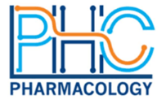
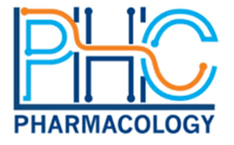

Course title: Regulatory Sciences for Healthcare Products in ASEAN

Course Description (Synchronous Online Course)
This course is designed for postgraduate students and professionals seeking to enhance their expertise in regulatory and safety sciences. It provides practical insights into the application of safety and regulatory sciences to ensure safety of health care products throughout their lifecycle. Participants will gain hands-on knowledge to navigate safety and compliance challenges in the healthcare industry, covering pharmaceuticals, medical devices, food supplements, herbal products, traditional medicines and cosmetics.

By the end of this course, participants will be able to:
- Understand the fundamental principles of regulatory and safety sciences and its role in ensuring the safety of healthcare products in ASEAN markets.
- Apply safety and regulatory sciences to assess and manage risks across pharmaceuticals, medical devices, food supplements, herbal products, traditional medicines, and cosmetics.
- Analyze safety regulations and compliance frameworks governing healthcare products in ASEAN markets.
- Develop practical skills to interpret safety data, evaluate regulatory information, and make informed decisions for product safety and compliance.

Target Audience
Regulatory affairs professionals, health authority officers, toxicologists, chemical safety analysts, risk assessment specialists, R&D scientists, medical doctors, pharmacists, healthcare professionals, educators

Target date and time
June 3, 4, and 5, 2025 (3 days)
Three-hour sessions (11:00 AM-2:00 PM, Singapore time)
Topic | Content | Lecturer | Time & Date
Day 1
Toxicology: Application of science to safety assessment | -Fundamental concepts used in risk assessment, management, and communication  -Applications of toxicology | Soga Kwon, National University of Singapore | 11:00 AM-12:00 PM, June 3, 2025
Regulatory overview for health care products | -Foundation of Regulatory sciences for health care products  -Overview of ASEAN regulation on health care products | Noppadon Adjimatera, ASEAN & North Asia (Japan, Korea, Hong Kong, Taiwan) Regulatory Affairs and Safety (RAS) Director, Reckitt, Thailand | 12:00 PM-1:00 PM, June 3, 2025
Regulation & safety assurance requirement of pharmaceutical products | -Foundation of Regulatory sciences for Pharmaceutical  -ASEAN regulation on Pharmaceutical  -Safety requirement of pharmaceutical | Rahul Chauhan, Head of Regulatory Affairs, for I-SEA region, Takeda, Singapore | 1:00 PM-2:00 PM,  June 3, 2025
Day 2
Regulation & safety assurance requirement of medical devices | -Foundation of Regulatory Sciences for medical devices  -ASEAN regulation on medical devices  -Safety requirement of medical devices | Chadaporn Tanakasemsub (Miang), Head of Regulatory Affairs, APJ Vision, Johnson & Johnson MedTech, Singapore | 11:00 AM-12:00 PM, June 4, 2025
Regulation & safety assurance requirement of herbal products and traditional medicines | -Foundation of Regulatory sciences for herbal products & traditional medicines  -ASEAN regulation on traditional medicines  -Safety requirement of herbal products & traditional medicines | Chen Woei Lee  ASEAN Regulatory Affairs Category Head for Health Care & Compliance, Reckitt, Singapore | 12:00 PM-1:00 PM, June 4, 2025
Regulation & Safety Assurance Requirement of cosmetic products | -Foundation of Regulatory Sciences for cosmetics  -ASEAN regulation on cosmetics  -Safety requirement of cosmetic products | Willy Chin, P&G, Singapore | 1:00 PM-2:00 PM, June 4, 2025
Day 3
Regulation & Safety Assurance Requirement of food supplements | -Foundation of Regulatory sciences for food supplements medicines  -ASEAN regulation on food supplements  -Safety requirement of food supplements | Sylvia Tsai, SEAT BU R&D and Wider Asia Regulatory Strategy Lead at Haleon, Taiwan | 11:00 AM-12:00 PM, June 5, 2025
Pharmacovigilance | - Introduction to – pharmacovigilance  - Adverse drug reactions, Signal detection, risk assessment, management, and communication,  -Case examples | Dorothy Toh, HSA, Singapore | 12:00 PM-1:00 PM,  June 5, 2025
Assessment | Twenty (20) multiple-choice questions | Soga Kwon, National University of Singapore | 1:00 PM-2:00 PM,  June 5, 2025

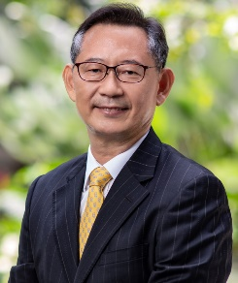
Dr. Seok (Soga) Kwon serves as an Associate Professor in the Department of Pharmacology, Yong Yoo Lin School of Medicine, National University of Singapore. Before he joined the National University of Singapore, Soga dedicated 24 years of his career to working as an industrial toxicologist at Procter & Gamble (P&G), specializing in Global Product Stewardship within the Research & Development division. Soga has played a pivotal role in organizing the annual Asia safety expert workshop, a critical platform for risk communication and collaboration among safety and regulatory experts across Asia. Additionally, Soga serves the advisory board for a project titled “Collaboration to Harmonise the Assessment of Next Generation Evidence” led by the Norwegian Scientific Committee for Food and Environment. He also chairs the Read-Across Work Group at the Korean Society of Toxicology, facilitating scientific collaboration among safety and regulatory experts from both public and private sectors. This group acts as a think tank, providing scientific consultation to stakeholders, including regulatory authorities. He also served on safety advisory committees at the National Institute of Food and Drug Safety Evaluation and the National Institute of Environmental Research in the Republic of Korea. Soga completed a postdoctoral fellowship in the Endocrine, Reproductive & Developmental Toxicology Program at the Chemical Industry Institute of Toxicology (CIIT) in North Carolina, USA, and a visiting fellowship in the Laboratory of Reproductive & Developmental Toxicology at the National Institute of Environmental Health Sciences (NIEHS), part of the National Institutes of Health (NIH) in North Carolina, USA. He earned his Ph.D. from the University of Illinois, at Urbana-Champaign, USA.

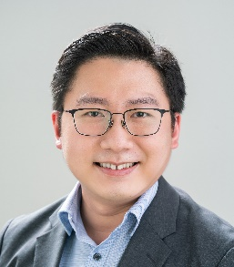
Dr. Willy Chin is a Senior Scientist in the Global Product Stewardship Department of Procter & Gamble and based in P&G Singapore Innovation Center. He has close to 7.5 years of professional experience in Asia-Pacific regulatory compliance management and provides regional regulatory consulting and expertise to support end-to-end innovation in beauty care, with a focus on skin and hair care brands. He is an executive committee member of The Cosmetic, Toiletry and Fragrance Association of Singapore (CTFAS) and in July 2023, was appointed as a committee member of the ASEAN Cosmetics Association (Safety & Toxicology Working Group). He is currently also an adjunct lecturer at Singapore Polytechnic for the Advanced Diploma in Specialty Chemicals programme where he teaches on cosmetic products regulations in Asia. Willy obtained his Bachelor of Applied Science (Honours) in Applied Chemistry from NUS in 2011 and was subsequently awarded NUS Graduate School for Integrative Sciences & Engineering (NGS) Scholarship to pursue a Ph.D. in Polymer Science and Engineering. He has culminated 5 years of multidisciplinary academic and international industrial research experience in the design and development of synthetic polymers for anti-microbial, water purification and drug delivery applications.


Assoc Prof (Adj) Dorothy Toh is currently the Assistant Group Director of the Medicinal Products Pre-market Cluster at the Health Products Regulation Group (HPRG), Health Sciences Authority (HSA). Being a strong advocate for public health and safety, Dorothy promoted the safe use of health products through various consumer education and media platforms. Together with her colleagues, she initiated the use of data mining and analytics of de-identified health records for pharmacovigilance purposes. Her team was also awarded the Inaugural Mrs Tan Shook Fong – Pharmaceutical Society of Singapore Innovative and Scientific Research Award, for successfully implementing new pharmacogenetics testing protocols that significantly optimised patient outcomes through the reduction of serious adverse events.


Rahul Chauhan is a Regulatory Affairs and Pharmacovigilance professional with in-depth knowledge and experience in Pharmaceuticals, Biologicals, OTC, Medical Devices, Ayurvedic Preparations, Cosmetics, Pesticides, and Consumer Goods. He held the leading executive role in major pharmaceuticals and FMCG companies including MSD, Eli Lilly and Reckitt Benckiser. He is currently the Head of Regulatory Affairs, for I-SEA region at Takeda, based in Singapore. He graduate with B.Pharm from Chaudhary Charan Singh University, India, and also with PGDBM from Management Development Institute, Gurgaon, India. He also gets qualification as Regulatory Affairs RAC (Drug) from RAPS.

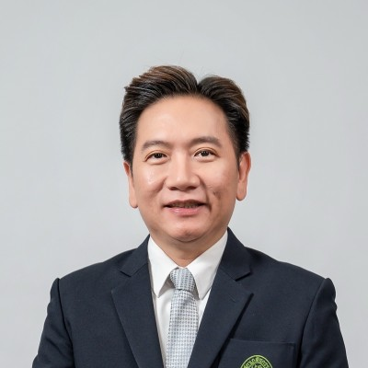
Dr Noppadon (Nhum) Adjimatera is a registered Thai pharmacist from Chulalongkorn University, Thailand with PhD in Pharmacy from University of Bath, UK, and MBA/LLB (Laws) from Thailand. Currently he leads the ASEAN & North Asia (Japan, Korea, Hong Kong, Taiwan) Regulatory Affairs and Safety (RAS) Department at Reckitt, covering various healthcare product categories. Prior to this role, he has intensive experiences in global regulatory affairs, scientific affairs, product safety, and government relations in P&G and PepsiCo. He is also the President of TSMIA, and positions in various industry& professional associations to drive for excellence in healthcare regulatory framework & regulatory professional. He is currently the 2nd Vice President of Thailand Pharmacy Council (National Pharmacist Board), covering the policy & standard development/implementation for pharmacy professionals and public health excellence.


Ms Sylvia Tsai, currently hold the role as SEAT BU R&D and Wider Asia Regulatory Strategy Lead at Haleon, based in Taiwan. She leads the R&D and regulatory strategy for the SEAT region. She also has the extensive regulatory affairs & product development experience in Wyeth, Pfizer, GSK, for various product category, such as OTC, supplement and personal care products. Her educational background includes Bachelor of Science in Pharmacy, Taipei Medical University, and Master of Business Administration (EMBA), National Taiwan University. She is also elected as the President of Taiwan Self Care Industry Association (TSCIA), and actively works as the board of director in other industry associations including Taiwan Pharmaceutical Marketing and Management Association (TPMMA), Asia Pacific Self-Medication Industry (APSMI). Global Self-Care Federation (GSCF).


Ms Chadaporn Tanakasemsub (Miang) is the 25 years-experience professional in Asia Pacific, Japan, China and Russia Regulatory Affairs, Clinical Research, Reimbursement and Quality Assurance in the Pharmaceutical, Medical Device Industries. Currently she holds the position of Head of Regulatory Affairs, APJ Vision, at Johnson & Johnson MedTech, based in Singapore. Her expertise includes the strategic direction, plan and execute broad, multidisciplinary projects of healthcare products. She also heavily involves with numbers of harmonization activities including IMDRF, GHWP and ASEAN harmonisation. The current position is a chair of APACMED RA committee and a president of GHWP ASL. She held the leading executive role in major pharmaceuticals and medical devices companies including Johnson & Johnson, Alcon, Zimmer, Cardinal Health. She is a registered Thai pharmacist with BSc Pharm Sciences from Chulalongkorn University, Thailand with MBA from Mahidol University, Thailand.

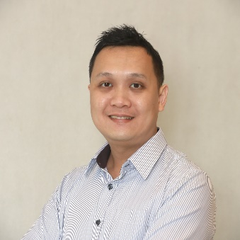
Mr. Chen Woei Lee is the ASEAN Regulatory Affairs lead for Health Care category at Reckitt. With over 12 years of experience in the consumer healthcare industry, his current portfolio includes OTC medicine, medical devices, health supplement and cosmetic products. He graduated from National University of Singapore with Pharmacy degree and is currently a registered pharmacist with Singapore Pharmacy Council and Pharmacy Board Malaysia.

