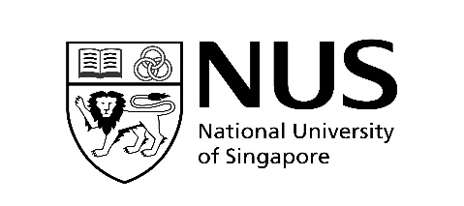

WONG HOCK BOON SOCIETY

Conference / Workshop Report Form

The report form should be submitted after your conference / workshop to:

Yong Loo Lin School of Medicine, Dean’s Office, Research Division

Attn: Ms Sherline Tay Gek Sun (medtgss@nus.edu.sg)
Mr Cheng Woon Tien (woontien@nus.edu.sg)

Name: |  | Student Matriculation No.:
Year of Study: | M1 M2 M3 M4 M5 | Contact No. (mobile):
Email Address:
Project Title:

Conference / Workshop Title:
Venue: |  | Date:
What you have learnt from the Conference / Workshop that is related to your work?
What you have learnt from the Conference / Workshop and how it has helped you in your research project?

