The Asia-Pacific Scholar

Guidelines for Multimedia Article (MA)

A short video/animation of not more than 7 minutes elaborating the scholarly work that you have embarked on. It could be:
A) Explaining your work, highlighting the key findings and the main conclusion(s) using a video format.
B) An introduction to an article which you have published in TAPS, where the author(s) highlight the key findings and the main conclusion(s) using a video format.
C) An introduction to an article which you have published in other journals, where the author(s) highlight the key findings and the main conclusion(s) using a video format. However, it is mandatory that written permission must be obtained from the journal publisher.
Interested authors are welcome to write in to enquire at tapsenquiry@nus.edu.sg.

Guide to Authors
- Either in main text or a separate page/template.
- The author(s) must provide a clear narration of the visual content. Small text to be omitted as it will make reading difficult.
- Authors will have to obtain the appropriate permissions from the publisher if any images from previously published papers appear in the videos. DO NOT include other copyrighted images, sounds or music.
- Videos should be uploaded to YouTube and not other video hosting services, nor as files sent directly to TAPS.
- A transcript to the video must be provided for accessibility requirements.
- Do include a direct link to your paper if it’s already published, or add this detail later when your article is published.
- All video abstracts will be evaluated for quality and relevance.
- TAPS reserves the right not to publish the video abstract if the criteria above are not met.

Template Guidelines
- Abstracts should follow the heading format of ‘Introduction’, ‘Methods’, ‘Results’ and ‘Conclusion’.
- Note. Authors are strongly encouraged to include in their paper stronger conclusions and tie to action or application to demonstrate clear regional relevance and raise the value/potential impact of their work when submitting to TAPS.
- Authors should also indicate/describe in their video article, their respective individual role(s) and contribution(s) to this submitted Multimedia Article. It is insufficient to state "All authors involved in conceptual development, data collection, data analysis, read and final approved of the manuscript."
For example, Author A reviewed the literature, designed the study, conducted interviews, analysed transcripts and wrote the manuscript. Author B developed the methodological framework for the study, performed data collection and data analysis as her PhD research project, and developed the manuscript. Author C advised the design of the study, gave critical feedback to the writing of the manuscript and conducted interviews. All the authors have read and approved the final manuscript.
- For all manuscripts, standard institutional review board (IRB) procedures must be followed and approval obtained by the author(s). This needs to be highlighted at the time of submission for TAPS review consideration. It is compulsory for authors to provide in their submission to TAPS, the Approval Number or Waiver Letter/Email provided by their respective Review Board in their ethical application outcome. Failure to do so might result in the rejection of the paper.
- State funding source(s) for this paper or research study.
- Authors must state all possible conflict of interest, including financial, consultant, institutional and other relationships that might lead to bias or a conflict of interest.
- Arrange the list of references in alphabetical order of the family name/surname of the first author at the end of the paper. All reference items should be in 9 point font. Please use APA 6th edition referencing. Example: Author, A. A., Author, B. B., & Author, C. C. (Year). Title of article: Title II. Title of Journal spelt out in full, volume number(publication issue), xxx-xxx. Note the character spacing; letter capitalisation; placement of punctuations such as full stops, commas and colons; specific parts of reference to be italicised; and full pagination. For more information, refer to http://libguides.nus.edu.sg/APA6th and below examples.
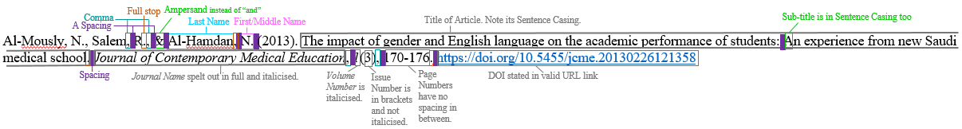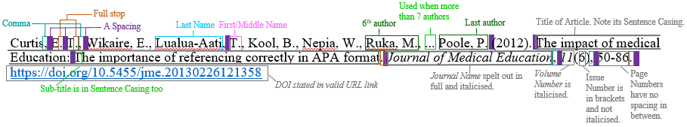
- All references cited in the body of paper as in-text citations have to be in APA 6th Edition referencing system. For the different cases of in-text citations, refer to http://libguides.nus.edu.sg/APA6th.
- All manuscript should have 1 corresponding author assigned to liaise with TAPS for review, formatting and proofreading. Author’s details should include full name, institution address, contact number (optional) and/or email address.

*All authors please take note that any manuscript which does not comply with the above guidelines will result in administrative delay in review processing.

Multimedia Specifications Format
Below is the list of formats acceptable for TAPS journal.
Format | Extension | Details
MP4 | MP4 | Preferred video format; H.264+AAC, max target 720p
MPG | MPG | MPEG-1 or MPEG-2 format required; highest possible quality required
Apple QuickTime | MOV | Refer https://support.apple.com/downloads/quicktime
Microsoft Audio/Video Interleave | AVI | Refer https://docs.microsoft.com/en-us/windows/win32/directshow/capturing-video-to-an-avi-file

Multimedia Specifications Guideline
- Frame rate: 25–30 frames per second
- Video codec: H.264 (+AAC) preferred
- Aspect ratio: 16:9 or 4:3, square pixels, deinterlaced
- Key frame: at least every six seconds
- Video bitrate: 480–2672 kbps
- Audio bitrate: 16-bit AAC audio at a sampling frequency of 44.1 kHz
- Bitrate of 192 kbps
- Maximum file size: One single file with maximum 150 MB
- Video Bit rate: at least 260 kbps (750 kbps preferred)
- Recommended frame size: 320 × 240 pixels
- Duration: no more than 7 minutes

Tips for Making a Multimedia Article
- Use a tripod to stabilise your video.
- Use enough light during recording (avoid any bright light coming from behind the person being interviewed (windows, sunlight).
- Speaker should not stand too close to walls to avoid shadow and possible echo effects.
- Speak clearly and loudly enough for recording. Use of a microphone is recommended, but do not place it too close to your mouth to avoid breathing noises.
- Clearly state the names of the spokespersons and provide titles etc.
- Do not carry out your recording near construction site or on rainy days to avoid background noise.
- Edit your video to improve the recording. You can make use of software such as Adobe Premiere Elements, Windows Movie Maker, iMovie, Final Cut Pro, Cinelerra and others.
- For slides conversion, you can use Microsoft Mix, Camtasia, Adobe Captivate, TechSmith Snagit and others.

Instructions for Author Submission and Review Process:
- Authors send View Only link to video from your own NUS nBox / Google Drive / Dropbox / YouTube.
- TAPS Editorial Office admin will check criteria of video fit and invite reviewer to review the video.
- Reviewer(s) will go to link to review (have to be internal reviewers because granting a specified reviewer the view access will reveal identity of reviewer).
- Revisions, if any, will be made known to authors for further amendment.
- Once revised video is accepted, authors will be informed to grant View and Edit access.
- Admin will download video and upload the video to TAPS YouTube channel and CenMED Scholar.
- Journal coordinator will include the link in TAPS electronic copy.

