H1 Main Title (20px)

Justin Lee¹, Xiao Ming Huang² & John Smith²

¹Department of Medical Education, Faculty of Medicine, University of AAA, United Kingdom; ²Centre for Health Sciences, University of BBB, Australia

Keywords: Medical Education, Health Profession Education…, 10TH (Min: 3 Keywords, Max: 10 Keywords)

H2 Header (14px)
H3 Sub-header (11px, bold)
Please type here… (11px, regular)

H2 Header (14px)
H3 Sub-header (11px, bold)
Please type here (11px, regular)

H2 Header (14px)
H3 Sub-header (11px, bold)
Please type here (11px, regular)
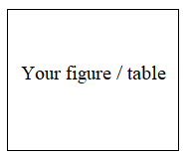
Figure/Table 1. A line graph using colours
Please type here (11px, regular)

Reference Style - Cite sources in Chicago style, place a superscript number at the end of a sentence or clause, after the punctuation mark, corresponding to a numbered footnote. Footnotes appear at the bottom of each page. Refer to an example below. To automatically generate accurate references, you can use Scribbr’s free Chicago Citation Generator. Only 5 references allowed.
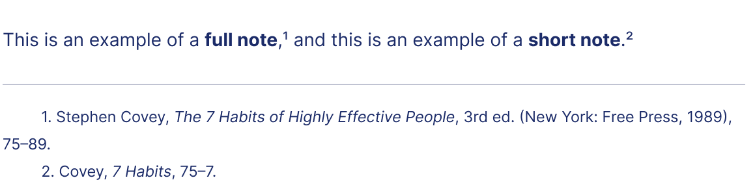

Notes on Contributors
Each author should describe his or her(s) role(s) in and contribution(s) to the submitted manuscript, with a maximum of 50 words on each contributor.

Acknowledgement
Specify acknowledgements with regard to technical help and/or financial and material support or contributions that do not justify authorship.

Funding
State funding source(s) for this paper or research study.

Declaration of Interest
Authors must state all possible conflicts of interest, including financial, consultant, institutional and other relationships that might lead to bias or a conflict of interest.

*Name of Corresponding Author:
Institution Address:
Contact No (Optional):
Email:

